How to Use UM*Events Tutorial

UM*Events is a very useful tool to advertise for group mass meetings, auditions, concerts, and all other events. All campus events that are sponsored by MSA-registered student orgs are accepted to be posted on the site. This online events calendar is very beneficial since it is a centralized place for the public to visit and get information about events related to our a cappella groups.

Other benefits to posting on UM*Events is that if your events are arts and culture related, as a cappella events are, then in addition to being listed on UM*Events, the information will be transferred to the Arts at Michigan website and listed there as well. The a cappella events information, gathered from UM*Events, will also be used as the calendar on the MACC website. Therefore, arts and culture events can reach three prospective audiences!

There are four ways to get to UM*Events:
www.umich.edu/~umevents http://events.umich.edu
There is also a link on our website: www.umich.edu/~umsing
And there is a link from CTools (authorized for MACC council members) which also provides links to posting and searching events

- Your organization must be registered with MSA and only authorized signers can login onto the site.
- After login, you can check your account and preferences. This is the feature that allows you to manage your ownership and memberships to organizations
  - You can add members to an account by selecting an organization that you own and add members’ uniqnames.
- You can add an event by clicking on the “add an event,” or you can view your events that have already been posted, and even search for other events.
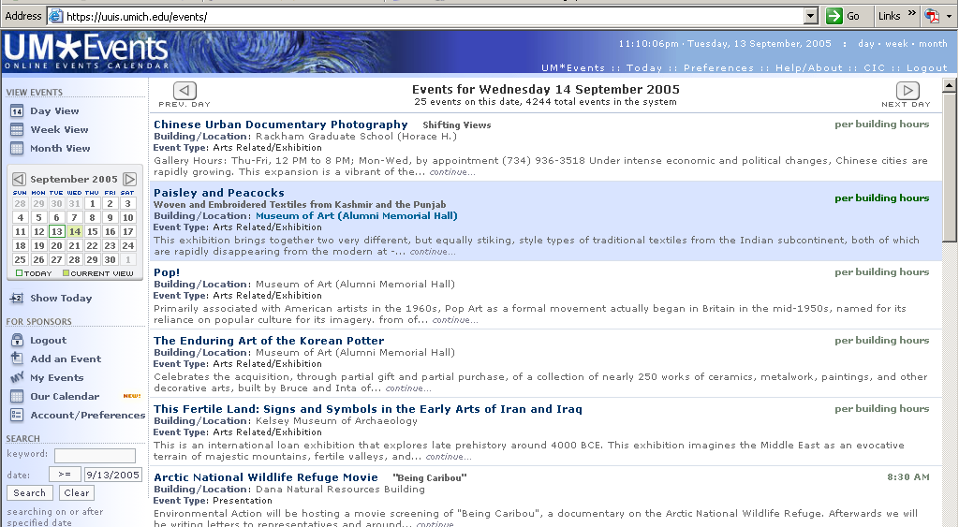

Add an Event
Search for an event
My Events

How to Add an Event

- When you click on “Add an Event” you will get the following window:
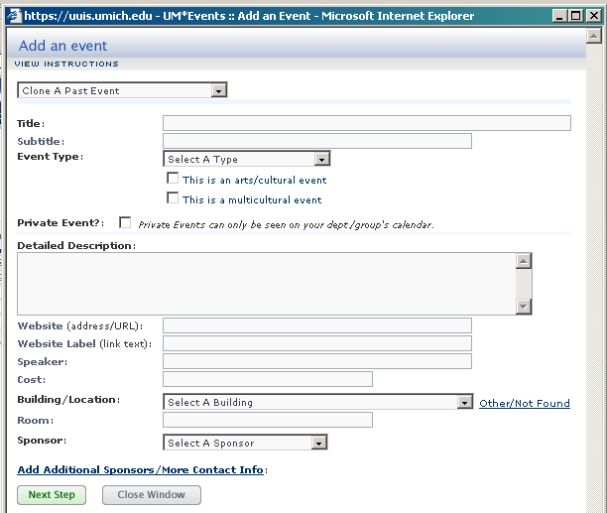
Mark as arts/cultural event
- You can select a past event. If the past event is listed in the first pull-down menu, then the rest of the page will fill out automatically.
- If not, then you can fill in the following boxes to create a new event.
- Make sure if it is an a cappella event to mark it as an “arts/cultural event”
- The next step is to set the event dates and times. (shown in picture)

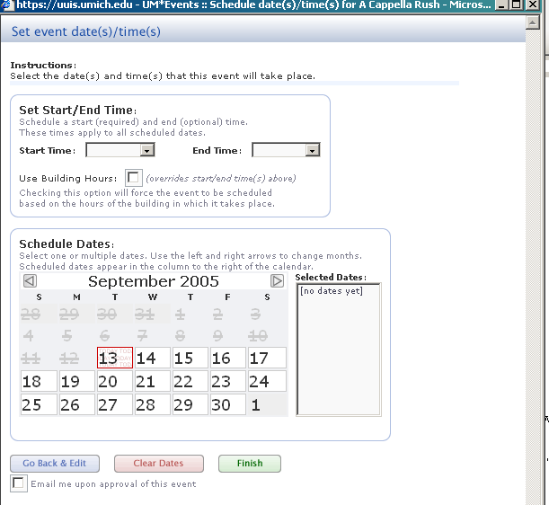
Set the starting time and ending time for event
Select which dates for event
Can select for UM*Events to email when the event is approved

